AUTH-010
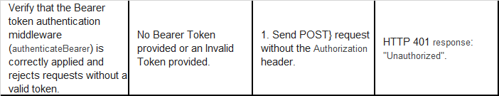
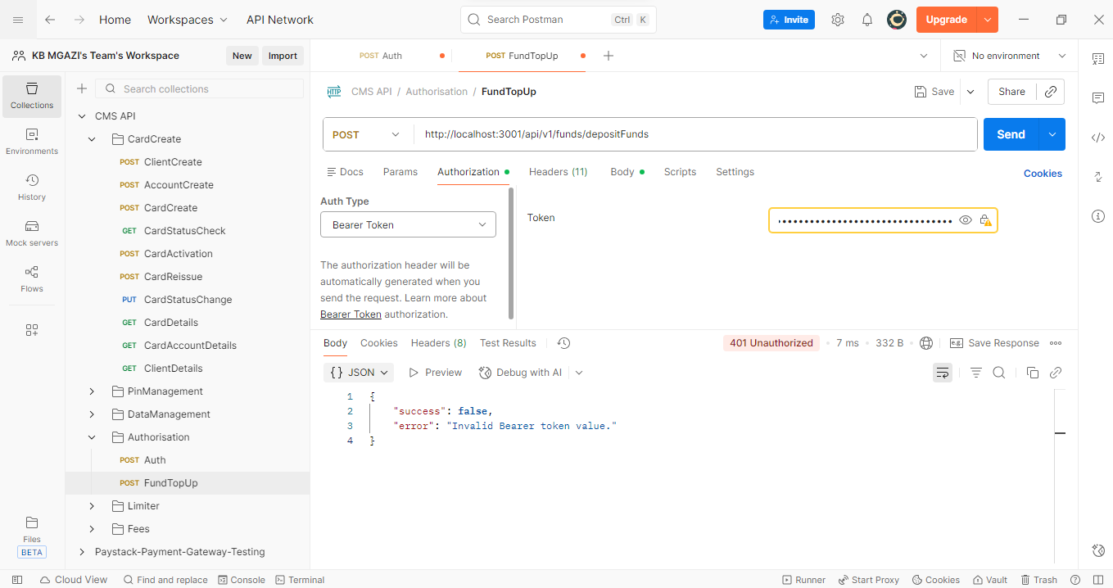
Response:
{
"success": false,
"error": "Invalid Bearer token value."
}

